Job Market Analysis & Future Prediction System

1. Problem Statement:
Job seekers face difficulty in identifying in-demand skills, high-paying countries, and future job trends.

2. Solution: Analyzed 244,828 jobs from Upwork dataset using Python, Pandas, and Scikit-Learn. Built a predictive model and deployed it using Flask and Docker.

3. Tasks Completed:
Task 1-2: Data Cleaning & EDA
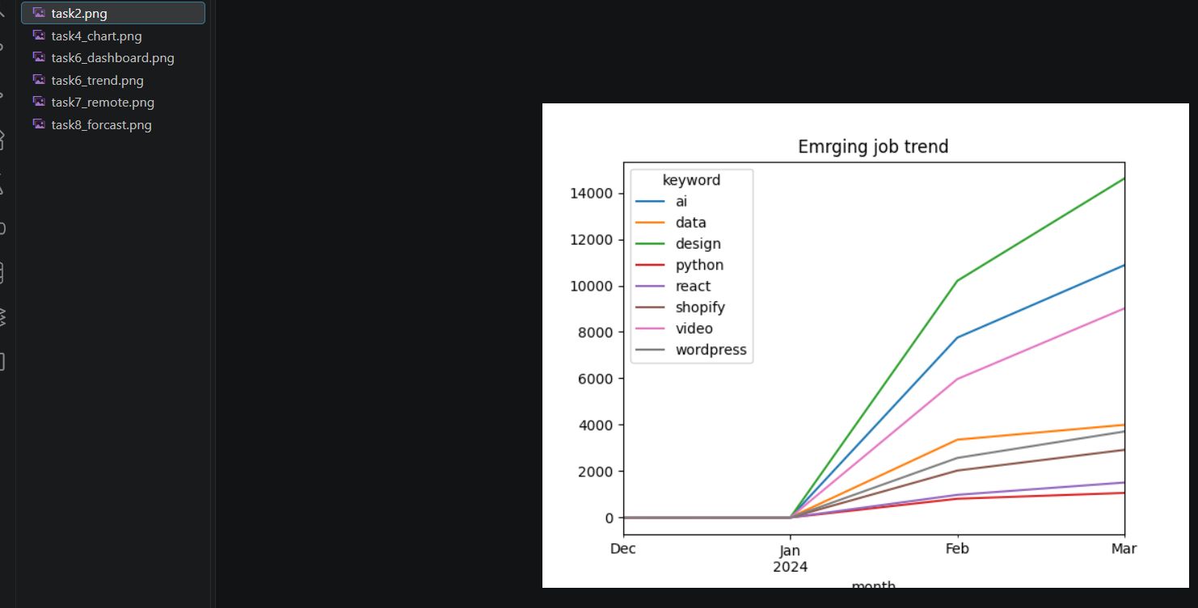

Task 3-5: Salary, Skill & Country Analysis

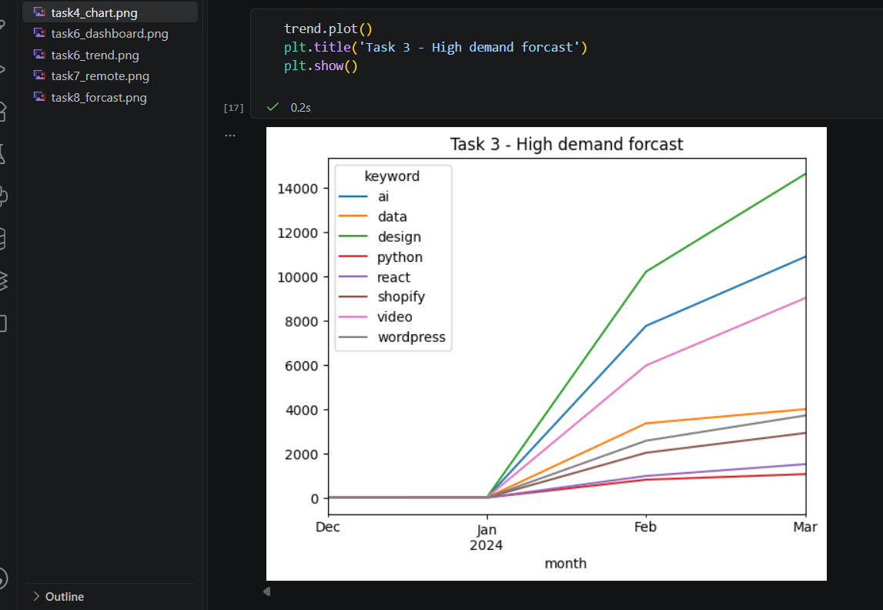
Task 6: Recommendation System
Task 7: Visualization Dashboard using Matplotlib & Plotly
Task 8: Future Prediction using Linear Regression4.
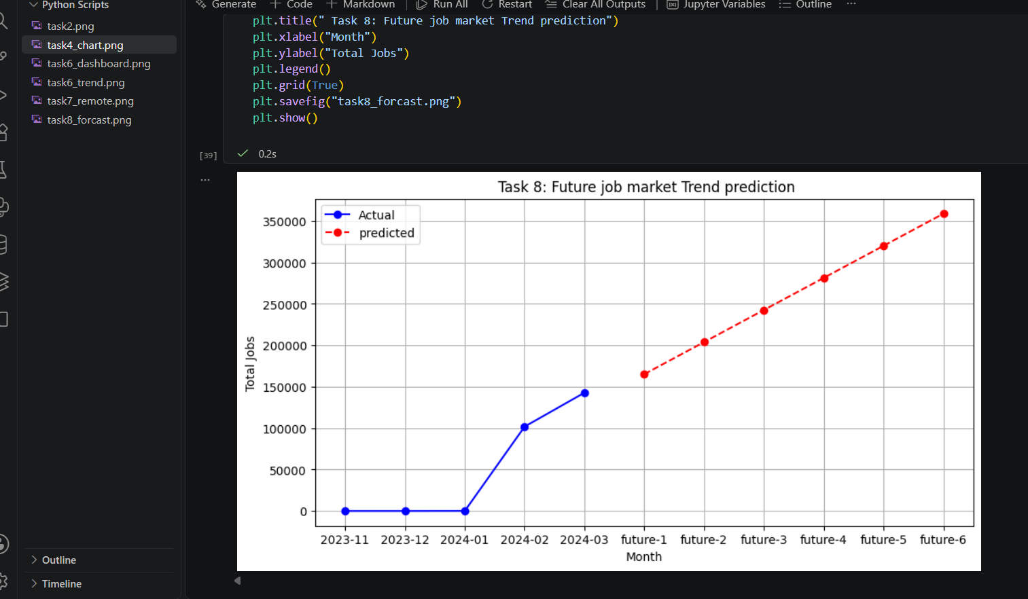
Key Findings:
Top Skills: Python, React, Shopify
Highest Paying Country: USA ($40+ avg hourly)
Prediction: Python, Data Science & AI will dominate for next 2 years
5. Tech Stack:
Python, Pandas, Scikit-Learn, TensorFlow, Matplotlib, Seaborn, Plotly, Flask, Docker
6. Deployment:
Application is containerized using Docker and Docker Compose for consistent deployment.
7. Conclusion:
This project provides valuable insights for job seekers and analysts through data-driven analysis and forecasting.

